Rank Badge with Leopard, Wave, and Sun Motifs

Students name:

Lecturers name:

Institution affiliation:

Course:

Date:

The striking pandemic of coronavirus has brought into light the ancient textile material with a long history with nothing in connection with the spread of the virus. The textile in question has a striking appearance of peace of art crafted with different images. The textile dates back to the 18th century, being held as a collection of the art's metropolitan museum. The textile is 10.75 by 11.25 inches in size and made of silk and metallic thread. It is an equivalent of a notebook paper in size. The objects of this nature are often known as the rank badges. They are mostly sewn in the court official robes in front and back, denoting the rank of the people wearing them as either civil or military. Having a node to the long-standing tradition of the animal depicted in Chinese art, the primary motif of rank badges is made of animals either real or imagined crafted within the badges (Weber, 2020 )
The central motif of the metropolitan museum textile is made of a leopard encrypted above the rolling waves. The leopard musculature and gapping jaws suggest a military rank officer. The Red Sun's presence at the upper right corner represents the emperor whom the court official is dully serving below him. The peaches appearing in the right upper corner of the badge represented longevity in addition to the swirling clouds. They clumped rolling waves that mimic bracket shaped form of lingzhi fungus. The Lingzhi fungus is believed to have medicinal value in traditional medicine such as anticancer, blood glucose regulation, antiviral, and antibacterial therapy (Weber, 2020 ). Lastly, the textile has flying bats around the landscape, highly suggesting the leopard watchfulness acting as an indicator of a promised future. According to the Chinese wordplay, the word bat, known as "fu," is a homonym referring to a promising future. Also, the flying bats suggest the descend of happiness from heaven (fúzĭ tiānlái)
A rank badge is a symbolic representation won by different people in different countries to indicate their position, especially in the military. The badge can be used to disclose the position of a government official. The formation and use of rank badge have different meanings and different materials used in manufacturing. For instance, a ceremonial uniform has a more colorful and larger rank badge than a simple combat uniform. The rank badges can either be metal, woven, machine embroidered, or hand made on bullion wire. According to the British army, the rank system forms the army structure's backbone, differentiated by unique badge rank distinguishing different army positions such as major, lieutenant colonel, and colonel from other officials. The army is made of two distinctive tiers the officers and other ranks; officers are the highest in the hierarchy, indicating they hold authority. The other ranks referred to enlisted soldiers of the army do not hold offices of power. The soldiers rank are marked by a title and set of symbols, and officers wear their logo on their shoulders or chest while other ranks at the sleeves.
The rank badge serves several factors, such as representing the organization's emblem, an accomplishment of a given operation or task. It is also used as a symbol of authority obtained through taking an oath such as in the police service and can be used as a sign of legitimate employment in a given organization and the employed status. From the late 14th century to the early 20th century, the Chinese used the ornate rank badge known as the buzi crafted with fierce animals to indicate military officials, bird species indicated by civic officials. Simultaneously, the exotic and imaginary creatures represented the imperial court members (Mair and Mair 2020). Basing on the university of Michigan museum of art, the leopard and tiger shared the third and fourth rank during the Ming dynasty. During the Qing dynasty, the tiger was a representative of the third rank. Late from 1662 to the end of the Qing dynasty, the leopard becomes a representation of the third military rank. The changes in the military rank animal symbols differed with the ruler; such changes are critical studies of different rulers with the rank symbol they used to illustrate authority and power.
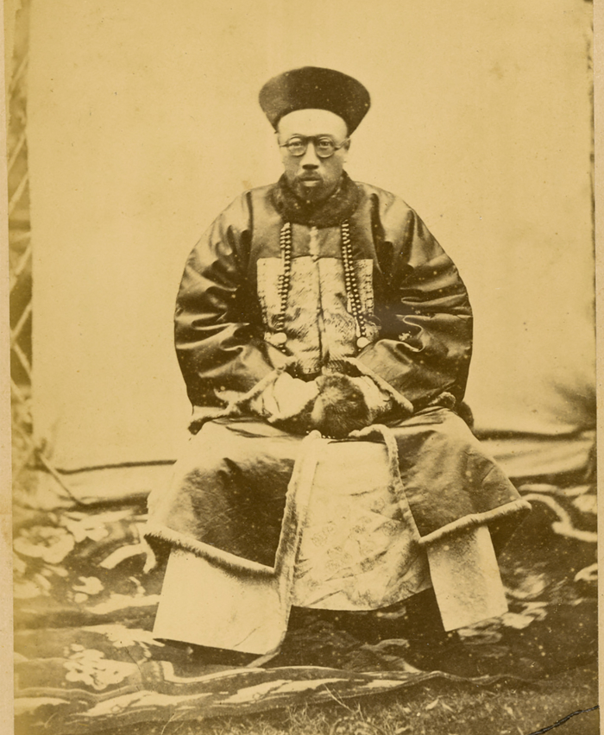
Figure 1: Portrait of Hankou Daotai, a Chinese Official, in Official Winter Uniform with Embroidered Badge of Office on His Chest and Court Beads. Hankou, Hubei Province, China, 1874

Scientific analysis of rank and status suggested the symbolic presentation of the birds and other animals is used as zoonotic carriers to transmit viral infection that causes respiratory tract infection in humans. For instance, some birds symbolizing official civic ranks are known to cause avian influenza viruses (Scoones, 2010). The bats, which represent a promising future, are engraved in almost all badges, acts as a reservoir of Hendra, Nipah virus, and severe acute respiratory syndrome (SARS). The CDC choose to use the rank badge to indicate animals' association with the pandemic originated from china and is a zoonotic disease from the bats that represent a promising future, terming the virus as a Chinese virus. The world health organization warns against such naming, suggesting they are worse than the virus. According to Breedlove and Fung, they noted, " Perhaps one's rank and status might confer favor in some circles, but they offer no protection from human-to-human transmission of SARS-CoV-2 and other viral respiratory infections and illnesses." It is essential to use the art to educate the young generation rather than politicking and causing hatred in the face of a pandemic.

References

British Army ranks. (n.d.). Retrieved October 21, 2020, from https://www.nam.ac.uk/explore/british-army-ranks
Mair, V., and Mair, V., 2020. Language Log » Bats In Chinese Language And Culture: Early Sinitic Reconstructions. [online] Languagelog.ldc.upenn.edu. Available at: <https://languagelog.ldc.upenn.edu/nll/?p=46910> [Accessed 20 October 2020].
Retrieved October 21, 2020, from https://www.cdc.gov/coronavirus/2019-ncov/cases-updates/summary.html
Retrieved October 21, 2020, from https://www.metmuseum.org/art/collection/search/68969
Scoones, I. (Ed.). (, 2010). Avian influenza: science, policy, and politics. Earthscan.
Weber, J., 2020. The CDC’S Misappropriation Of A Chinese Textile, And Why It Matters. [online] Hyperallergic. Available at: <https://hyperallergic.com/562771/emerging-infectious-diseases/> [Accessed 20 October 2020].

